**Assignment – 7**

**Practice Questions : 1**

**Q1) Accept a sentence from user and print its every word on separate line.**

**CODE :**

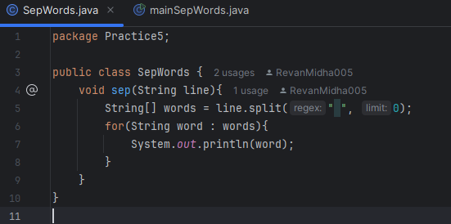

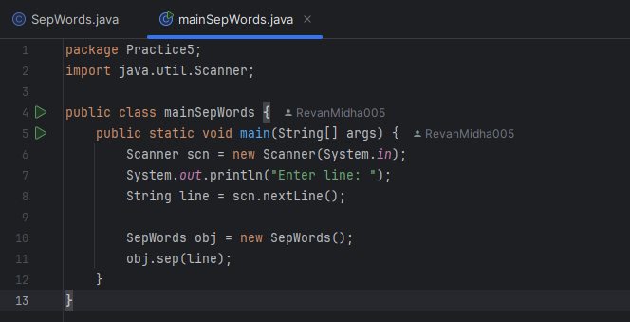

**OUTPUT :**

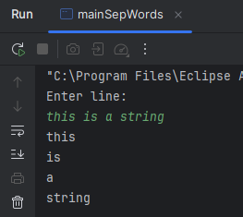

**HANDWRITTEN :**

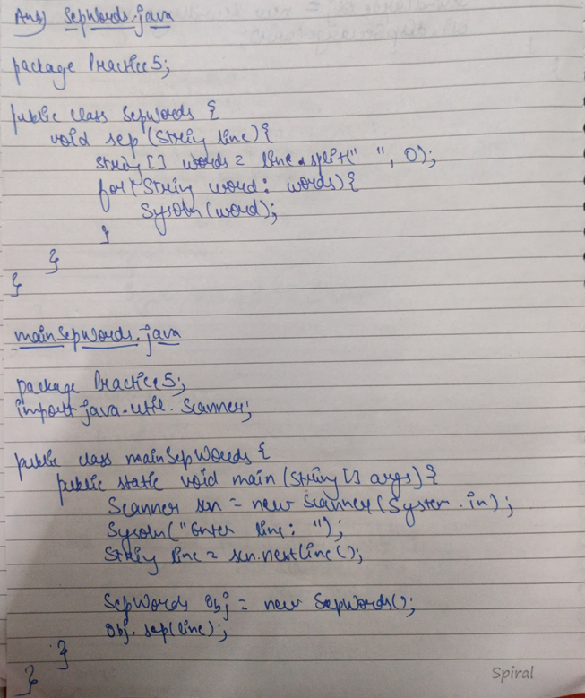

**Q2) Accept the name of the user and print all its character on different line.**

**CODE :**

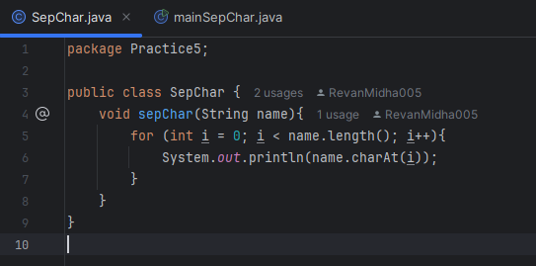

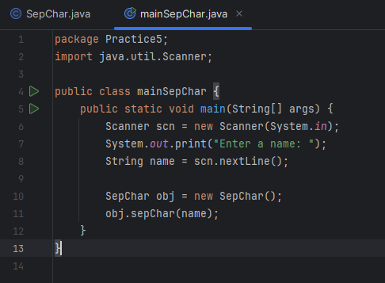

**OUTPUT :**

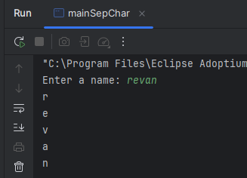

**HANDWRITTEN :**

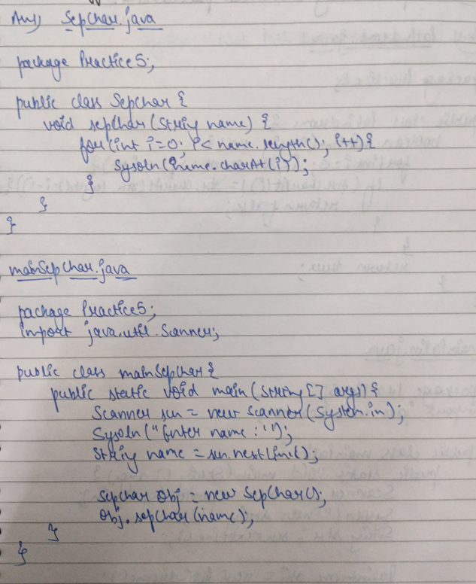

**Q3) Accept a string from user and check whether it is palindrome or not.**

**CODE :**

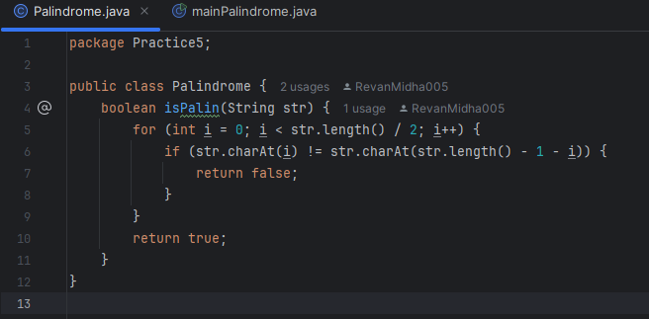

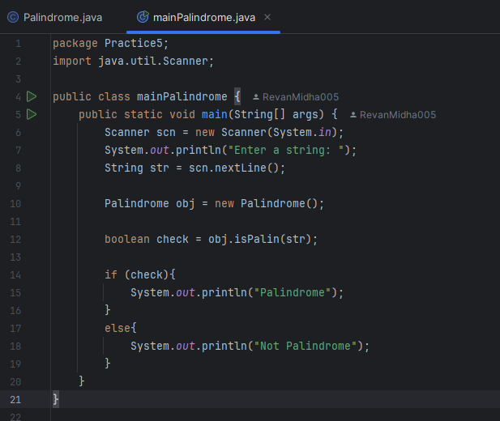

**OUTPUT :**

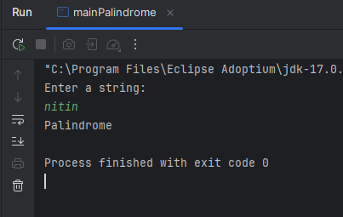

**HANDWRITTEN :**

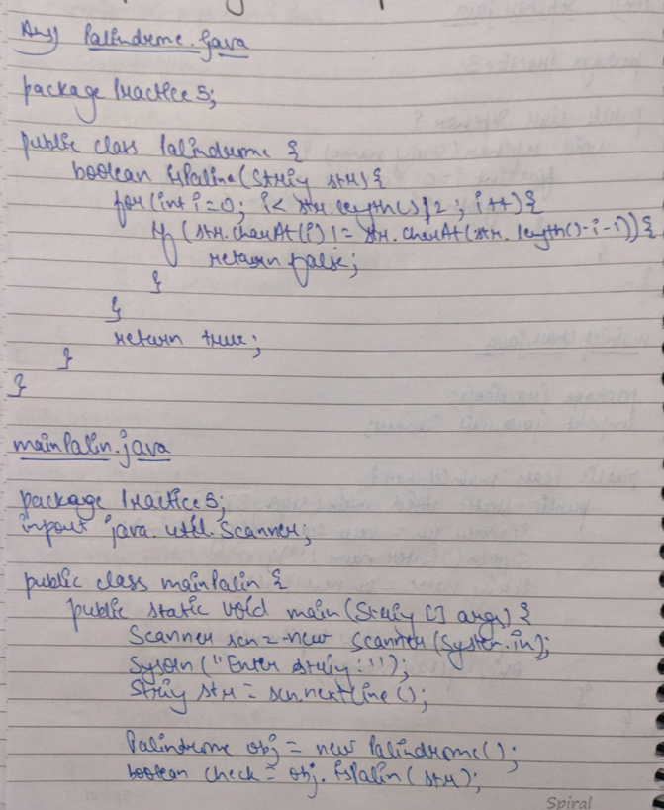

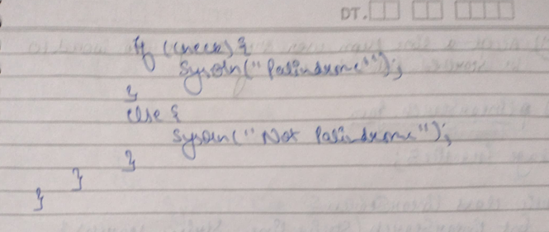

**Q4) Accept a line from user and then accept the word to be searched in it. Print the location of it.**

**CODE :**

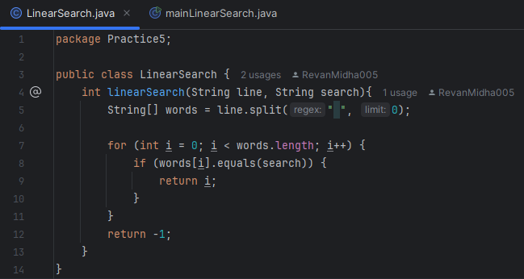

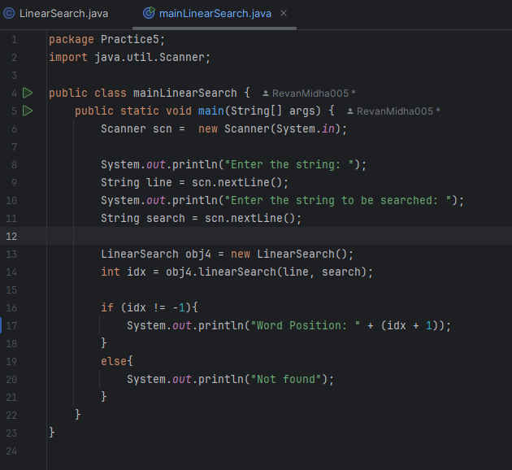

**OUTPUT :**

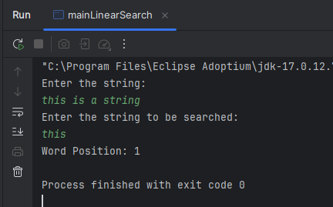

**HANDWRITTEN :**

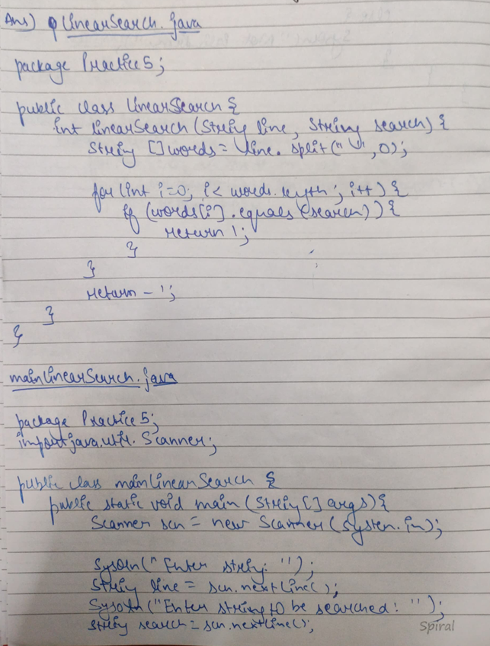

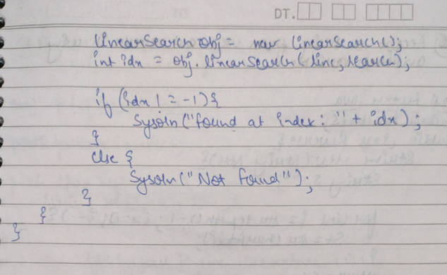

**Q5) Accept a String from user and reverse it without using another String variable.**

**CODE :**

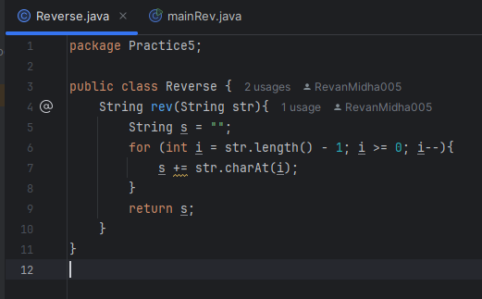

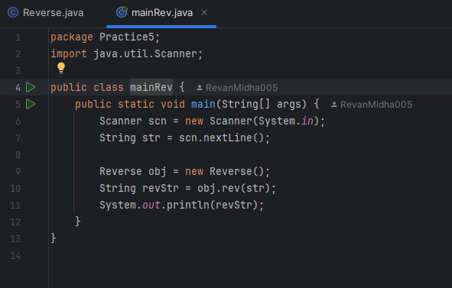

**OUTPUT :**

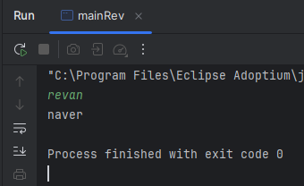

**HANDWRITTEN :**

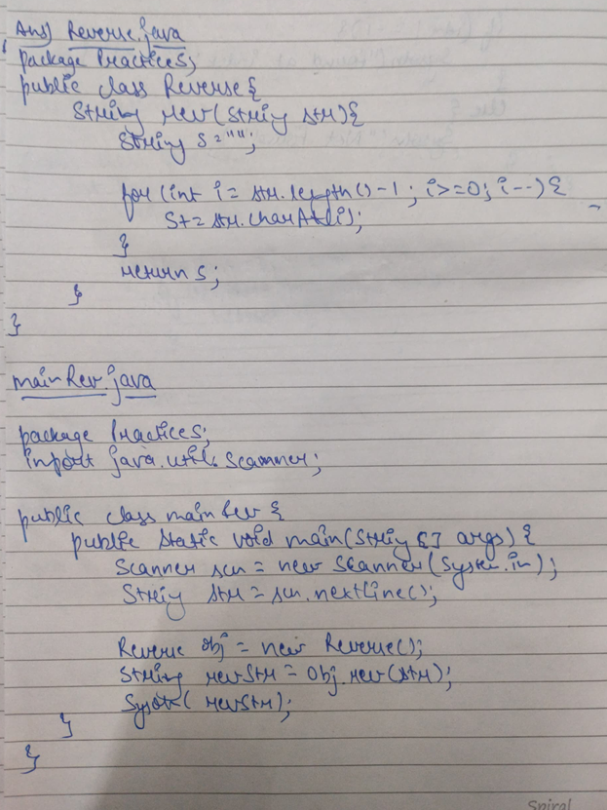

**Q6) Write a method to take input in two matrix from user and display the product of matrix**

**CODE :**

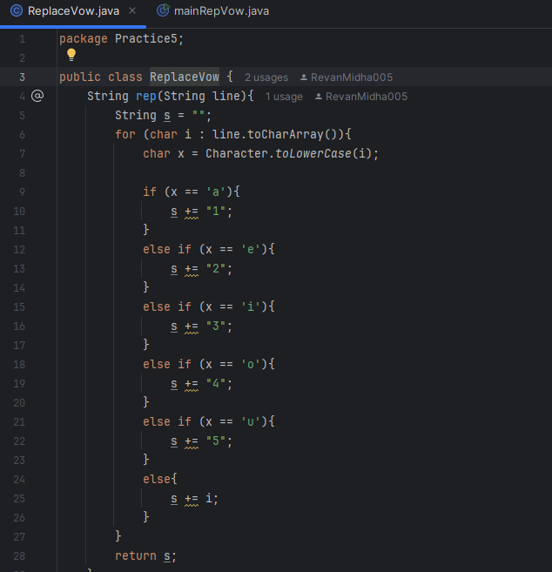

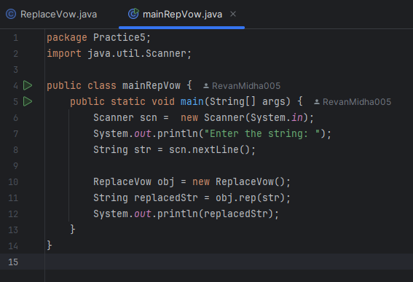

**OUTPUT :**

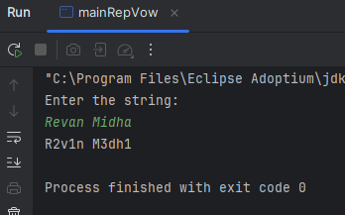

**HANDWRITTEN :**

